# User Manual

## 1. Introduction

### 1.1 Purpose

**Support360** is a comprehensive support management solution designed to streamline case and project tracking for teams. This software integrates with Salesforce to provide efficient case handling, project management, and reporting functionalities. Users can manage their tasks, collaborate with team members, and automate workflows, ensuring smooth business operations.

### 1.2 Audience

* **Team Members**: Regular users who handle cases, manage tasks, and track project progress.
* **Managers (System Admins)**: Users with administrative privileges to manage settings, users, and data.

## 2. Getting Started

### 2.1 System Requirements

To access Support360, ensure the following:

* A Modern web browser (Chrome, Firefox, Edge, or Safari).
* A stable internet connection.
* An active Salesforce license with assigned Support360 permissions.

### 2.2 Login Process

1. Open your web browser and navigate to the Salesforce login page.
2. Enter your username and password.
3. Click **Login**.
4. If Multi-Factor Authentication (MFA) is enabled, follow the on-screen instructions to verify your identity.
5. If you forget your password, click **Forgot Password?** and follow the reset instructions.

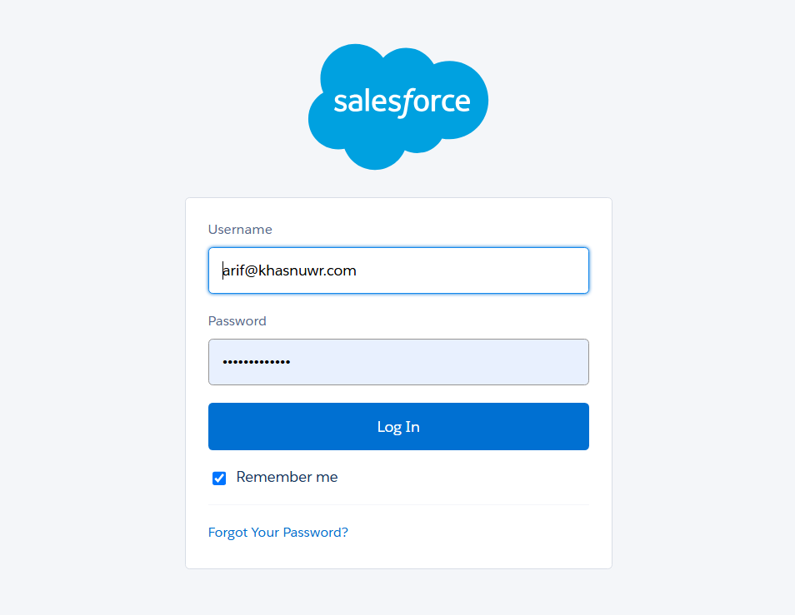

### 2.3 User Roles & Permissions

* **Team Member**: Can create, update, and track cases and projects.
* **Manager**: Has full access, including user management, Managing Projects, Allocate Resources to Project, Approves Changes, system settings, and data exports.

## 3. Navigation Guide

### 

### 3.1 Home Page Overview

Upon logging in, you will see the Support360 **Dashboard**, which includes:

* **Recent Cases & Projects**: Quick access to ongoing work.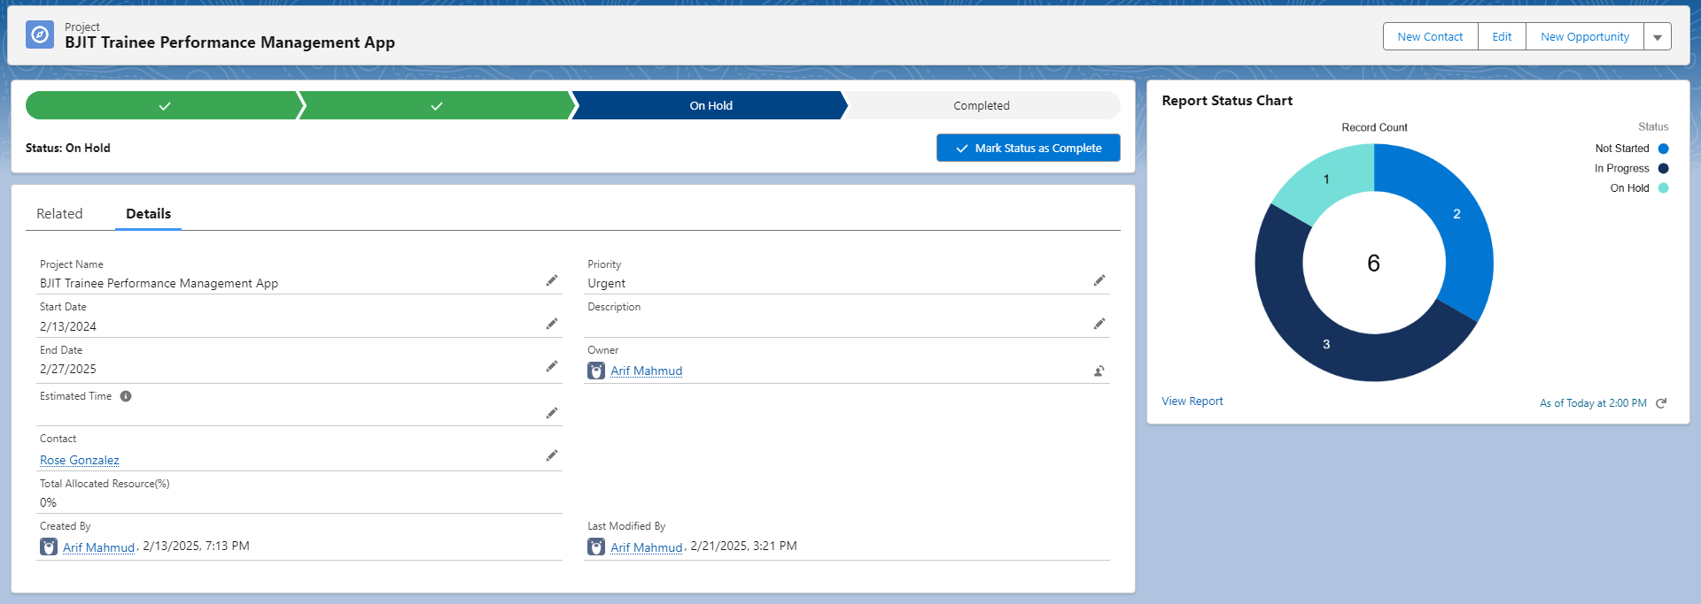
* **Request Approvals:** Ask for Approvals from Project Manager for Case/Task changes  
  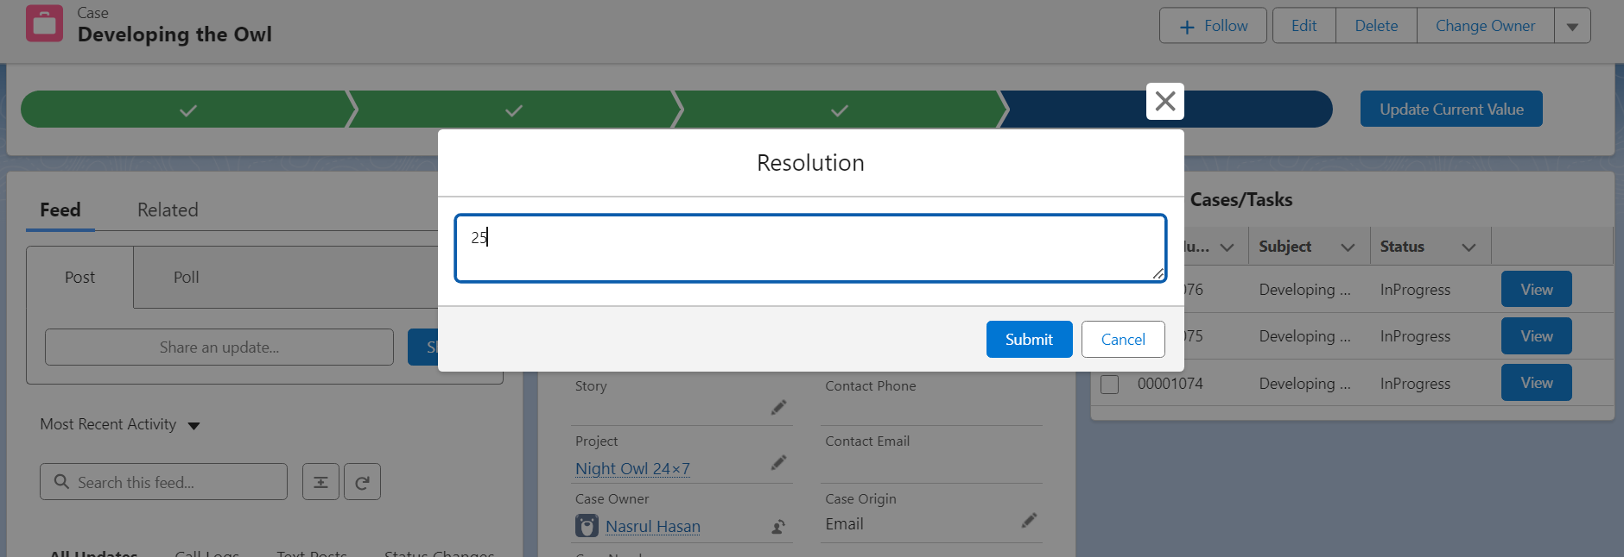
* **Pending Approvals**: Any cases requiring review, Approve, Reject, Re Assign, Comment (For **Project Manager Only**).

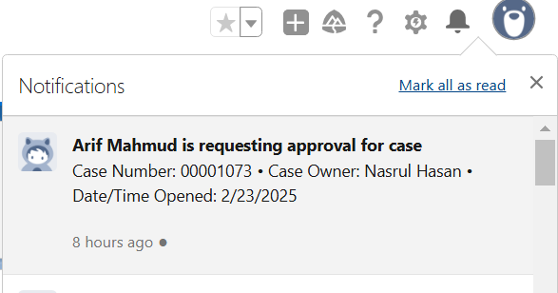 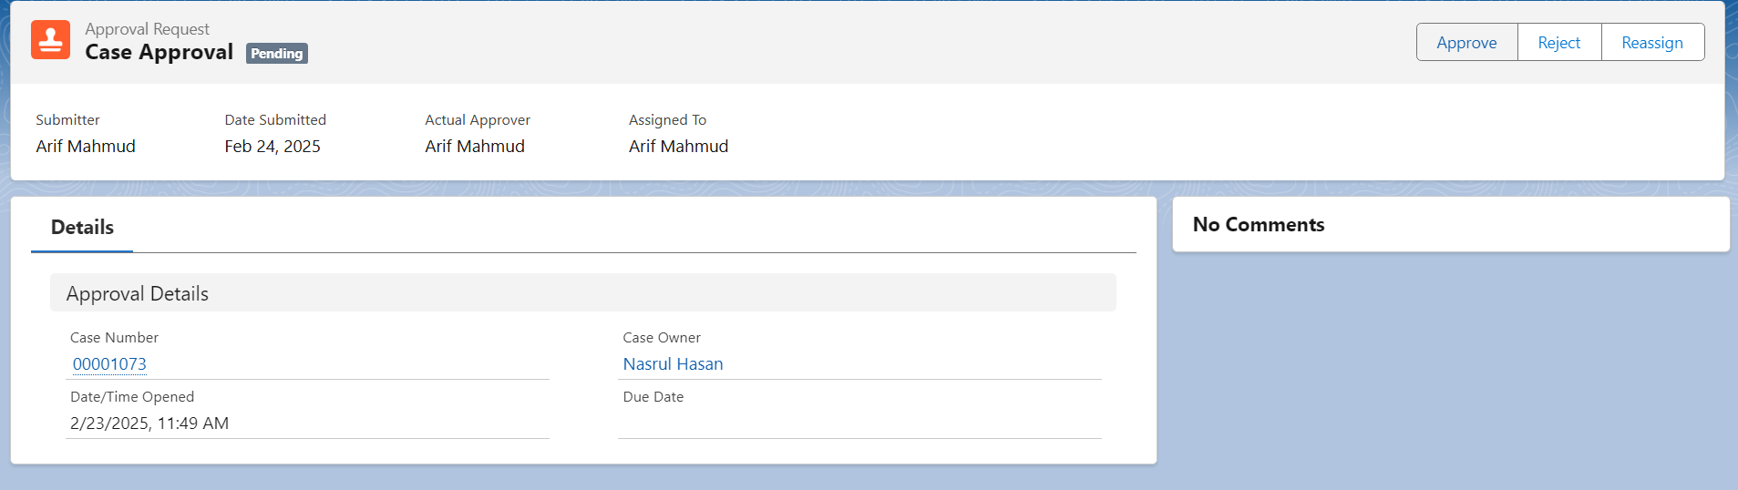

* **Reports & Metrics**: Key performance indicators and insights.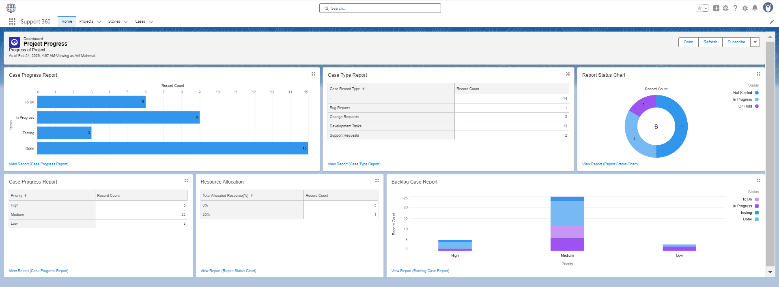

### 3.2 Menu & Features

* **Cases**: Manage support requests, development tasks, and issues.
* **Projects**: Track project milestones, assign resources, and manage deadlines.
* **Reports**: Generate insights into case resolution times and backlogs.
* **Settings**: Customize workflows, user permissions, and automation rules.

## 4. Key Functionalities

### 4.1 Managing Cases

* **Creating a Case**: Click **New Case from the Allocated Project Dashboard**, fill in the required details, and save.

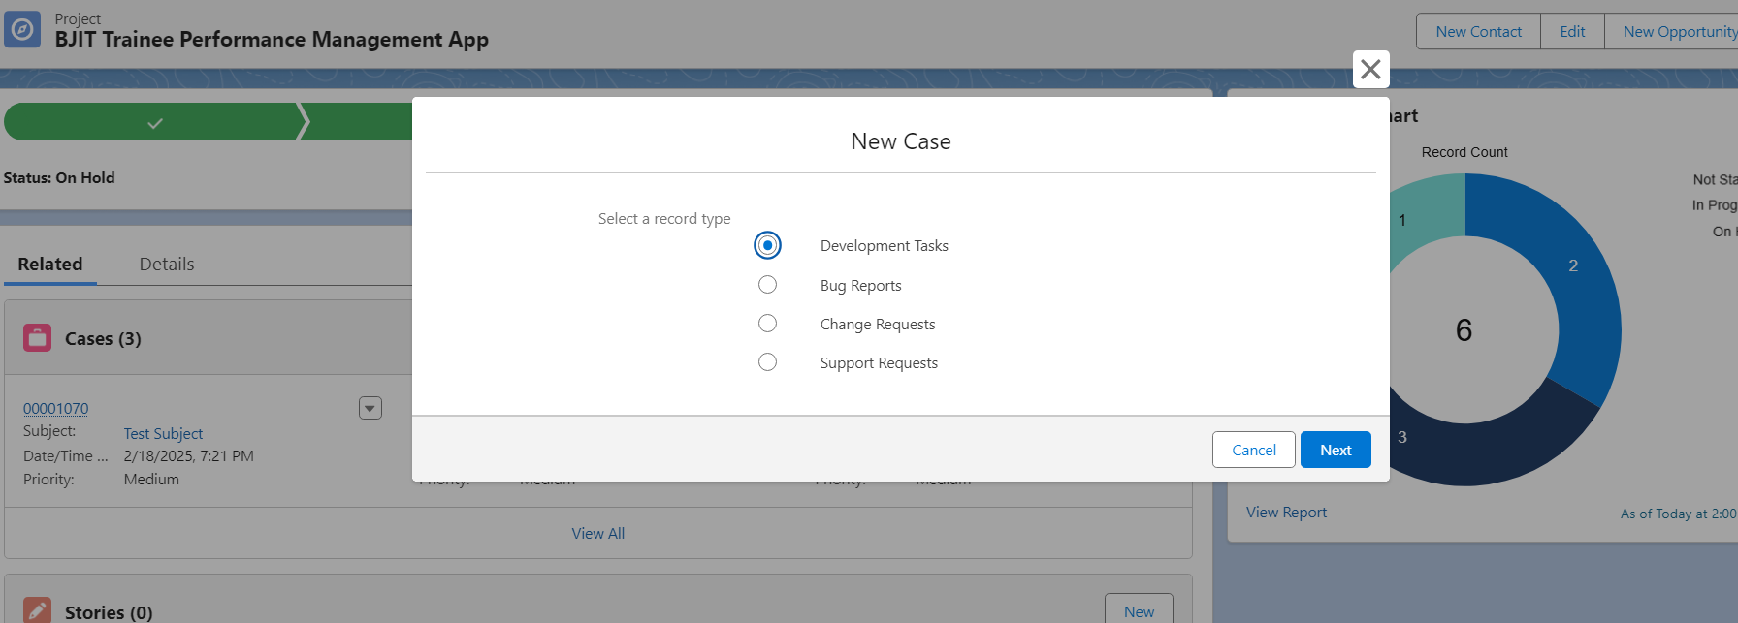

* **Updating a Case**: Navigate to a case, edit fields, and submit changes.
* **Assigning a Case**: Use the assignment dropdown to allocate tasks.
* **Closing a Case**: Mark a case as **Done** once all tasks are completed.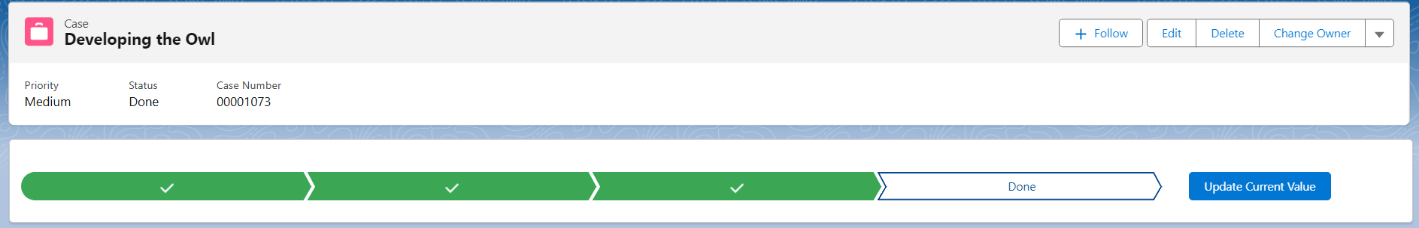

### 4.2 Project Management

* **Creating a Project**: Click **New Project**, enter project details.(Project Manager)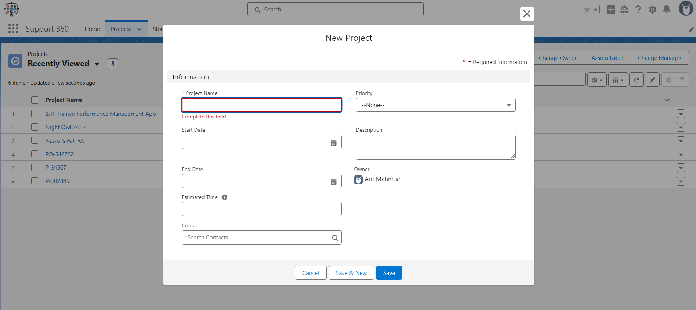
* **Tracking Progress**: View project dashboards and update statuses.
* **Change Manager:** Change Multiple Project’s Manager at a Time from “**Change Manager**” button.(Project Manager Only)

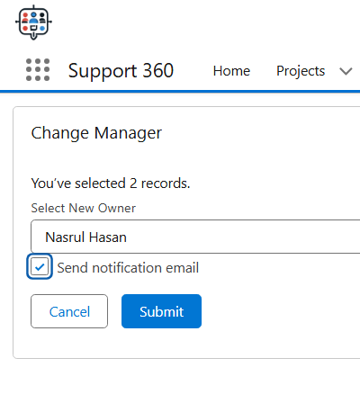

* **Assigning Team Members**: Add users to a project and set roles.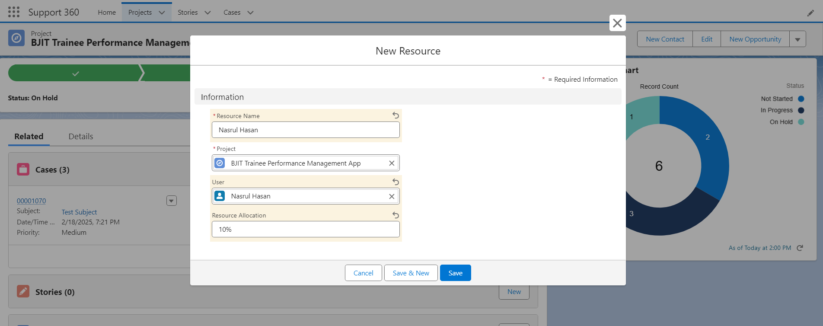

### 4.3 Reports & Dashboards

* **Generating Reports**: Go to **Reports**, select a template, and filter results.
* **Customizing Dashboards**: Use drag-and-drop widgets to personalize views.

### 4.4 Notifications & Emails

* **Receiving Notifications**: System alerts for case updates, attachments and approvals.
* **Email Alerts**: Automated emails for due dates, approvals, and assignments.
* **Email Reply Commands:** Manager Can Approve/Disapprove Changes By Replying Email Requested for Task/Case Changes.

## 5. Manager (Sys Admin) Controls

### 5.1 Project,Resource, Task Management

* **Adding Users**: Navigate to **Settings > User Management**, click **Add User**, and configure permissions.
* **Removing Users**: Select a user and click **Deactivate**.
* **Adding User to a Project:** Add/Remove user to a Project by Resource Allocation where the User will work as Team Member
* **Managing Project:** Create , edit, Track, Delete Project.
* **Approving Changes:** Approving Major Case/Task Changes Requested By Team Members

### 5.2 Data Management

* **Exporting Data**: Go to **Reports > Export Data**, choose a format, and download.
* **Managing Project Record Visibility**: Adjust sharing settings to control access levels.

### 5.3 Customization & Settings

* **Editing Page Layouts**: Modify case and project page layouts via **Settings > Layout Editor**.
* **Updating Workflows**: Automate tasks using **Process Builder or Flow**.

## 6. FAQs & Troubleshooting

### Common Issues:

1. **Forgot Password**: Use the **Forgot Password?** link on the login page.
2. **Case Not Updating**: Ensure you have the correct permissions.
3. **Report Not Loading**: Clear cache and refresh your browser.

## 7. Support & Contact Information

For further assistance, contact the Support360 help desk:

* **Email**: [arif.mahmud@bjitacademy.com](mailto:arif.mahmud@bjitacademy.com?subject=Hi,%20Im%20facing%20Problem), [smarifmahmud9@gmail.com](mailto:smarifmahmud9@gmail.com?subject=Hi,%20Im%20facing%20Problem)
* **Knowledge Base**: [SUPPORT 360 HELP](https://github.com/BJIT-Academy-24/YSD_B4_SF_Arif/tree/Arif_30214_final_project)
* **Live Chat**: Available during business hours via the Support360 portal.